Lab 5 – Function Pointers and RAII

Systems Programming (H) 2025–26

Introduction

The goals of this lab are to practice your C and C++ skills while working with function pointers, member functions and while applying the principle of RAII – ownership-based resource management in C++.
You can use clang++ to compile C++ code, instead of clang.
Task 1 – Work with function pointers
Write a C program that sorts an array of names. The names are implemented using the following struct:
struct name {
const char * first_name;
const char * last_name;
};
typedef struct name name;

The names should be first sorted alphabetically by first name and then printed. Then the names should be sorted and printed alphabetically by last name. Use qsort for sorting, by writing a comparison function that is passed as function pointer to qsort. You can use strcmp for comparing two strings. You can find some starting code in the file function pointers.c.
Here is a sample structure for your main function:
int main() {
name names[4] = {
{"Grace", "Hopper"},
{"Dennis", "Ritchie"},
{"Ken", "Thompson"},
{"Bjarne", "Stroustrup"},
};
// sort array by first name using qsort
// print array
// sort array by last name using qsort
// print array
}

Task 2 – Work with RAII – a buffer
Write a C++ program to implement a buffer with RAII. A buffer, in our scenario, stores integer values and can grow beyond the size initially allocated. You can find some starting code in the file buffer.cpp.
Here is a sample usage of the buffer:
int main() {
buffer b(3); // allocate a buffer with space for 3 ints
b.add(1); // add an element with a value of 1
b.add(2); // add an element with a value of 2
b.add(3); // add an element with a value of 3
b.add(4); // this call must allocate new memory
}

The Buffer should follow the RAII model: it should allocate memory in the constructor and free memory in the destructor as discussed in Lecture 5. The struct for the buffer should be based on the following prototype:
struct buffer {
int * ptr;
// ... maybe store some meta data
// constructor
buffer(int initial_size) {
// Allocate enough memory for the given initial_size
}
//destructor
˜buffer() {
// Free memory
}
void add(int element) {
// Check if there is enough room left in the buffer.
// If not, allocate new memory with enough space and
// copy all elements from the old memory over.
// Make sure not to leak memory!
}
};

A sidenote about C/C++
In C, it is common to add a line like typedef struct buffer buffer;, because if we do not create a typedef, we would have to refer to the structure as struct buffer. In C++, however, this is unnecessary. When you declare struct buffer, the name buffer automatically becomes a valid type name in C++ without needing an additional typedef.

Task 3 – Work with RAII – a DAG
Look at the picture of a directed acyclic graph below. In a DAG, no cycles or edges are allowed, and all edges are directed. Think about how to model ownership here.
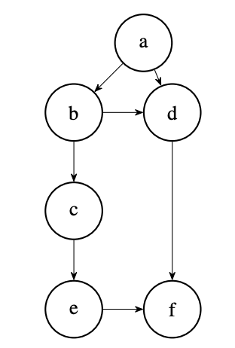
Design a node structure which uses std::unique_ptr or std::shared_ptr to express unique or shared ownership of a node. Only one option is appropriate there. Think about why.
A node should store a single value and many pointers to neighboring nodes. You can use a std::vector for storing the multiple pointers. When creating a node you should initialize the value. An add_edge_to( node_ptr ) member function should be implemented to create the graph structure.
You can find some starting code in the file dag.cpp. You can use the following main function for testing after replacing ?????? with either unique or shared:

int main() {
std::??????_ptr a = std::make_??????("a");
std::??????_ptr b = std::make_??????("b");
std::??????_ptr c = std::make_??????("c");
std::??????_ptr d = std::make_??????("d");
std::??????_ptr e = std::make_??????("e");
std::??????_ptr f = std::make_??????("f");

a->add_edge_to(b);
a->add_edge_to(d);
b->add_edge_to(c);
b->add_edge_to(d);
c->add_edge_to(e);
d->add_edge_to(f);
e->add_edge_to(f);
}

